**Assignment -1**

|  |  |
| --- | --- |
| Assignment Date | 16/11/2022 |
| Student Name | K.Sri Ram |
| Student Roll Number | 212219060137 |

**Question:**

To create a smart home using arduino in tinkercad. (Note: Use Minimum 2-3 sensors and an LED and Buzzer)

**Solution:**

**Circuit Diagram:**

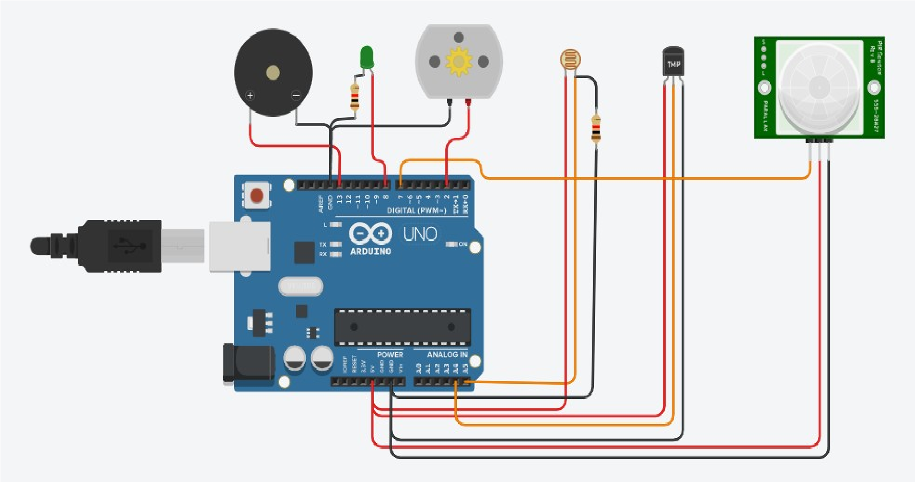

**Code:**

// C++ code

//

float x,y,z,temp; void setup()

{

Serial.begin(9600); pinMode(2, OUTPUT); pinMode(7, INPUT); pinMode(8, OUTPUT); pinMode(13, OUTPUT); pinMode(A4, INPUT); pinMode(A5, INPUT);

}

void loop()

{ x=analogRead(A5); y=analogRead(A4); z=digitalRead(7); temp = (double)y / 1024; temp = temp * 5; temp = temp - 0.5; temp = temp * 100; if(x<=550)

{

digitalWrite(8, HIGH); Serial.println(x); delay(1000);

Serial.println("Room is Dark..........Light's ON"); delay(1000);

} else {

digitalWrite(8, LOW); Serial.println(x); delay(1000);

Serial.println("Room is Light..........Light's OFF"); delay(1000);

}

if(temp>=30)

{ digitalWrite(2, HIGH); Serial.println(temp); delay(1000);

Serial.println("Temperature is High..........Fan ON"); delay(1000);

} else {

digitalWrite(2, LOW); Serial.println(temp); delay(1000);

Serial.println("Temperature is Low..........Fan OFF"); delay(1000);

} if(z>0) {

digitalWrite(13, HIGH);

Serial.println(z);

Serial.println("Someone is Entered........");

} else {

digitalWrite(13, LOW);

Serial.println(z);

Serial.println("No one is there........");

}

}

**Tinkercad Link:**

https://www.tinkercad.com/things/7G7NGHyALOr-brave-kup-curcan/editel?

sharecode=O7IHSdwPV7uu2-IGbmFMoruW9nmADd1tzGRPjCP5LXE